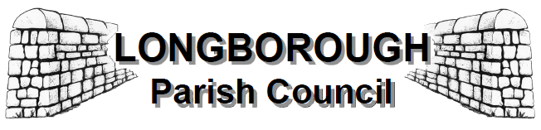

**Minutes of the Annual meeting of the Parish Council held on Monday 13th May 2024 at 7.15pm at Longborough Village Hall.**

Present: Cllrs: T Howse, A Driver, B Prior, and M Huttunen.

Also present: County Councillor Lynden Stowe and Clerk to the Council, Jenny Walsh. There were no members of the public present.

1. **Election of Chairman**

The Clerk commenced proceedings by asking for nominations for the position of Chairman of the Council.

Cllr Driver proposed Cllr Howse and was seconded by Cllr Green. There being no other nominees put forward, Cllr Howse accepted the nomination, was unanimously elected by a show of hands and took the Chair. Cllr Howse thanked his fellow Councillors for their support.

1. **Election of Vice Chair/s**

The Chairman asked for nominations for the two positions of Vice Chair for the Council**.** Cllr Howse proposed

Cllr Driver and was seconded by Cllr Green. Cllr Driver proposed Cllr Prior and was seconded by Cllr Howse.

There being no other nominees, Cllrs Driver and Prior both accepted the nominations and were duly elected following a show of hands.

1. **Dispensation requests**

There were no dispensations received. The Clerk reminded Councillors of their obligation to notify her of any changes to financial interests which must be recorded with Cotswold District Council’s Monitoring Officer.

1. **Apologies for absence**

Apologies were accepted from Cllrs Eddolls and Regan.

1. **Declarations of Interest**

There were no declarations made in relation to items on this agenda.

1. **Councillor Representatives on local bodies:**

Council agreed (subject to confirmation from Cllrs Regan and Eddolls who were not present at the meeting), that there would be no changes to the representatives established last year ie: Cllr Regan for Longborough Village School and St James church; Cllr Eddolls for the Village Shop and Cllr Prior for the Village Hall. Cllr Green would liaise with local businesses.

1. **Composition and representation on Parish Council Committees**

The Personnel Committee was the only committee at the Council, and it was agreed unanimously that the representatives would be Cllrs Howse, Cllr Driver and Cllr Regan, (subject to her agreement).

The meeting closed at 7.25pm

**Signed**

**Chairman Date**